Raspberry PI 4 Based Flight Simulator Instruction Manual.

School of Engineering and Material Science, Queen Mary University of London, Mile End Road, London, United Kingdom

Simulator Author: Prof. David J. Allerton - [d.j.allerton@sheffield.ac.uk](mailto:d.j.allerton@sheffield.ac.uk)

Instruction Manual by: Francisco R. Parra Perea – [f.r.parra-perea@qmul.ac.uk](mailto:f.r.parra-perea@qmul.ac.uk)

1. Hardware Used:

* Raspberry Pi 4 Computer Model B – 4GB RAM
* USB-C Power Supply for Raspberry Pi
* External Monitor (HDMI compatible)
* Mini HDMI to HDMI Cable
* External Keyboard & Mouse (Both connected through same usb port)

1. Instructions:
2. Homesim folder must be copied to a location within the Raspberry Pi 4.
3. The following commands must be run on a terminal to install required packages:

sudo apt search GLFW

sudo apt install libglfw3-dev

sudo apt glew

sudo apt install ligglew-dev

sudo apt install libglew-dev

sudo apt search libpng

sudo apt install libfreetype-dev

sudo apt search freeimage

sudo apt install libfreeimage-dev

sudo apt search alut

sudo apt install libalut-dev

sudo apt search openal

sudo apt install libopenal-dev

sudo apt search cglm

sudo apt install cglm-dev

sudo apt install libcglm-dev

sudo apt-get upgrade

1. Navigate to the folder b747 and run the demo

cd homesim

cd b747

./demo

An error regarding permission to run the file might appear. Simply navigate to the file demo on the path previously described, through the file manager, and access its properties, on the option run by: change to “anybody”

1. If the demo runs and a panel of instruments appear on the screen, then the simulator is working

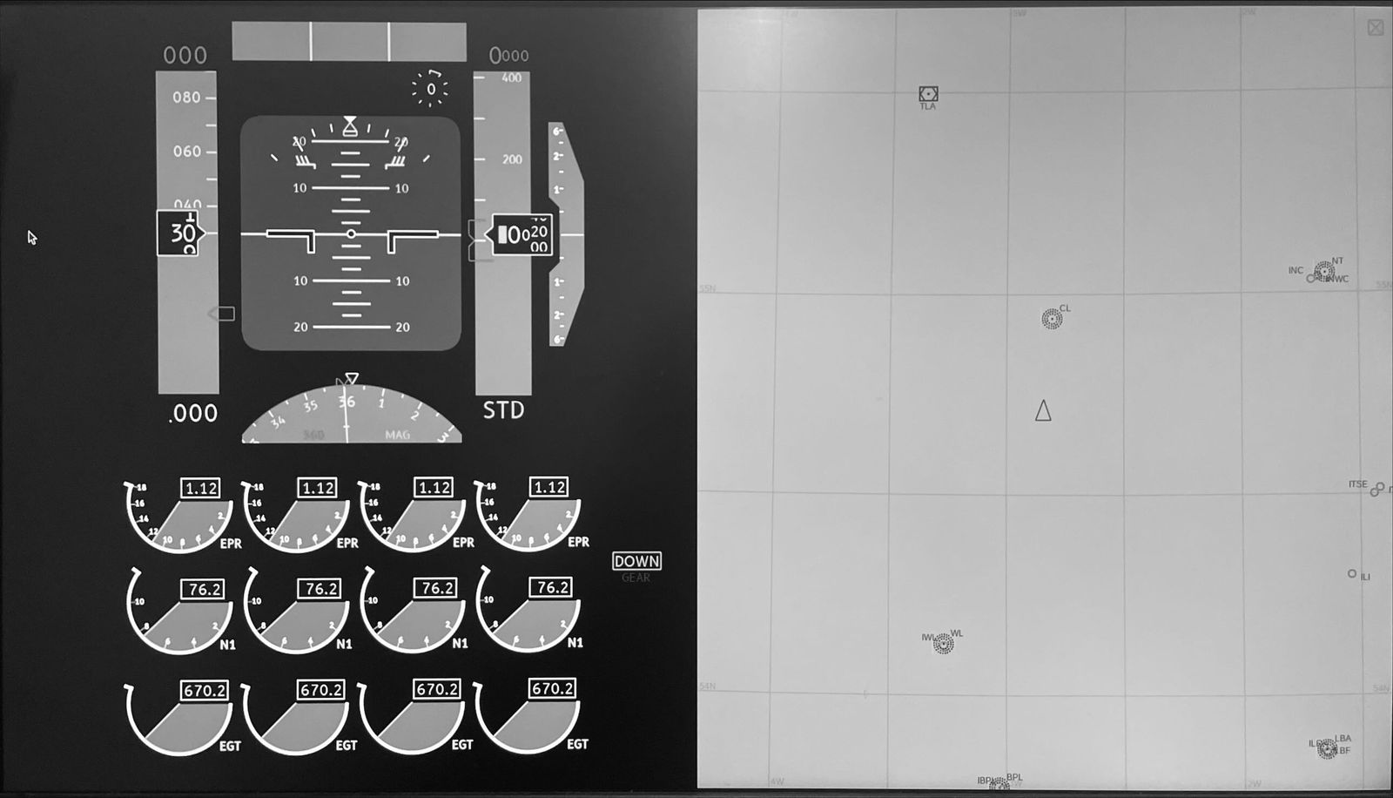

1. An IDE like Visual studio code can be installed to the Raspberry Pi to work on the simulator’s code. On the terminal run the following commands

Sudo apt update

Sudo apt install code

After the installation is completed, simply open the top left menu, click on programming, and then on Visual Studio code.

1. Make sure to install the C dependencies for VSC. Simply create or open a file or open a file with .c extension and the option to install c dependencies will appear.